Name: Mohammed Amaan
USN: 1BM23CS194
Date: 10/11/2025
BIS LAB TEST
Question
Optimize a traveling salesman's route to visit each city within specific time windows while minimizing the total travel distance using the Ant Colony Optimization method. Give its properly working code with output accordingly for the best path and best distance.

Code (Ant Colony optimization using time window)
import numpy as np
import random

# --- 1. Problem Setup ---

# City coordinates (x, y)
CITIES = np.array([
[0, 0], # 0: Depot
[10, 5], # 1
[3, 12], # 2
[15, 8], # 3
])
NUM_CITIES = len(CITIES)

# Time Windows: (Ready Time, Due Time) for each city
TIME_WINDOWS = np.array([
[0, 1000], # 0: Depot
[5, 20], # 1
[10, 30], # 2
[25, 40], # 3
])

def dist(i, j):
"""Euclidean distance (used as travel time)."""
return np.linalg.norm(CITIES[i] - CITIES[j])

# Pre-calculate Distance Matrix
D_MATRIX = np.array([[dist(i, j) for j in range(NUM_CITIES)] for i in range(NUM_CITIES)])

# --- 2. ACO Parameters ---
N_ANTS = 5
N_ITERATIONS = 30 # Reduced for faster quick run
ALPHA = 1.0 # Pheromone importance
BETA = 3.0 # Distance/Heuristic importance
RHO = 0.1 # Evaporation rate
Q = 100.0 # Pheromone deposit amount
PENALTY = 1000.0 # High cost for violating a time window

# Initialize pheromone matrix
PHEROMONE = np.ones((NUM_CITIES, NUM_CITIES)) * 0.1

# --- 3. Core TSPTW Cost & Heuristic Functions ---

def calculate_tour_cost(path):
"""Calculates total distance and time-window penalty."""
total_dist = 0
current_time = 0
penalty = 0

for i in range(len(path) - 1):
c_i, c_j = path[i], path[i+1]

travel_time = D_MATRIX[c_i, c_j]
arrival_time = current_time + travel_time
ready_time, due_time = TIME_WINDOWS[c_j]

# Service starts after arrival AND ready_time
start_service = max(arrival_time, ready_time)

# Check for violation
if start_service > due_time:
penalty += (start_service - due_time) * PENALTY

# Update time for the next leg
current_time = start_service
total_dist += travel_time

# Return to Depot is the last leg. The final current_time is the tour duration.
return total_dist, penalty

def get_attractiveness(i, j, current_time):
"""Heuristic (eta) that favors short distances and feasible times."""

travel_time = D_MATRIX[i, j]
arrival_time = current_time + travel_time
ready_time, due_time = TIME_WINDOWS[j]

# Hard constraint: if arrival is after the due time, the attractiveness is zero.
if arrival_time > due_time:
return 1e-10

# Waiting time: how long the ant must wait if it arrives too early.
waiting_time = max(0, ready_time - arrival_time)

# Attractiveness is proportional to 1 / (Distance + Waiting Time)
return 1.0 / (travel_time + waiting_time + 1e-6)

# --- 4. Main ACO Function ---

def solve_tsptw_aco_simple():
global PHEROMONE
best_path = None
best_cost = float('inf')

print(f"Starting ACO for TSPTW with {NUM_CITIES-1} cities.")

for iteration in range(N_ITERATIONS):
ant_tours = []
ant_costs = []

for ant in range(N_ANTS):
path = [0]
visited = {0}
current_city = 0
current_time = 0

# Build the path
while len(path) < NUM_CITIES:
unvisited = [c for c in range(NUM_CITIES) if c not in visited]
if not unvisited: break

probabilities = []
total_attractiveness = 0.0

for next_city in unvisited:
tau = PHEROMONE[current_city, next_city]
eta = get_attractiveness(current_city, next_city, current_time)
attractiveness = (tau ** ALPHA) * (eta ** BETA)
probabilities.append(attractiveness)
total_attractiveness += attractiveness

if total_attractiveness == 0:
next_city = random.choice(unvisited) # Fallback to random move
else:
probs = np.array(probabilities) / total_attractiveness
next_city = np.random.choice(unvisited, p=probs)

# Update state
travel_time = D_MATRIX[current_city, next_city]
arrival_time = current_time + travel_time
ready_time = TIME_WINDOWS[next_city][0]
current_time = max(arrival_time, ready_time) # Start service time

path.append(next_city)
visited.add(next_city)
current_city = next_city

# Close the loop by returning to Depot (City 0)
if len(path) == NUM_CITIES:
path.append(0)

# Calculate cost (Distance + Penalty)
distance, penalty = calculate_tour_cost(path)
total_cost = distance + penalty

ant_tours.append(path)
ant_costs.append(total_cost)

# Update best found solution
if total_cost < best_cost:
best_cost = total_cost
best_path = path

# Pheromone Update
PHEROMONE *= (1.0 - RHO) # Evaporation
for path, cost in zip(ant_tours, ant_costs):
if cost < float('inf'):
deposit = Q / cost
for i in range(len(path) - 1):
PHEROMONE[path[i], path[i+1]] += deposit

PHEROMONE = np.clip(PHEROMONE, 1e-4, 10.0) # Clip bounds

return best_path, best_cost

# --- 5. Execution and Output ---

best_path_found, best_optimized_cost = solve_tsptw_aco_simple()

if best_path_found and len(best_path_found) == NUM_CITIES + 1:
best_distance, penalty = calculate_tour_cost(best_path_found)

# Recalculate time for simple display
current_time = 0
for i in range(len(best_path_found) - 1):
c_i, c_j = best_path_found[i], best_path_found[i+1]
current_time += D_MATRIX[c_i, c_j]
current_time = max(current_time, TIME_WINDOWS[c_j][0]) # Account for waiting time
final_time = current_time

print("\n" + "=" * 40)
print("✅ **Simplified ACO TSPTW Result** ✅")
print("-" * 40)
print(f"**Best Route:** {' -> '.join(map(str, best_path_found))}")
print(f"**Minimum Distance:** {best_distance:.2f} units")
print(f"**Total Optimized Cost:** {best_optimized_cost:.2f}")
print(f"**Time Window Penalty:** {penalty:.2f} (Should be 0.00 for a feasible route)")
print(f"**Total Time for Route:** {final_time:.2f} units")
print("=" * 40)

else:
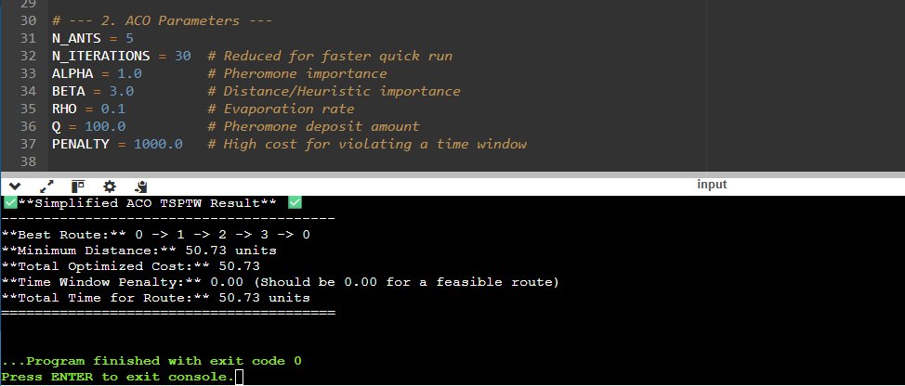
print("ACO failed to find a complete tour.")
OUTPUT:

